Task- 1 List 3 real-world devices in your home or college that use SMPS (Switched Mode Power Supply) and 2 devices that use UPS (Uninterruptible Power Supply), explaining in one line why each device needs that type of power supply.

Here are three devices that use a Switched Mode Power Supply (SMPS) and two devices that use an Uninterruptible Power Supply (UPS), along with a one-line explanation for each:

Devices Using SMPS (Switched Mode Power Supply)
- Desktop PC: Converts household AC power into multiple stable, regulated DC voltages (+12V, +5V, +3.3V) required by internal computer hardware.

- Laptop Power Adapter (Charger): Steps down and converts high-voltage AC mains power into safe, low-voltage DC power to run the system and charge the internal battery.

- LED TV: Supplies precise, regulated DC voltages needed to power the display panel, backlight LEDs, and internal logic boards.

Devices Using UPS (Uninterruptible Power Supply)
- Desktop Workstation: Provides emergency backup battery power during unexpected power outages to prevent data loss and allow for a safe system shutdown.

- College Server / Network Switch: Ensures continuous, uninterrupted network uptime and prevents connection drops or server corruption during power fluctuations.

Task-2 Draw and label a diagram showing the main internal components of a typical SMPS unit found in a desktop PC, including AC input, rectifier, transformer, and DC output sections.Hint: You can hand-draw and upload a photo, or use any free diagram tool like draw.io.

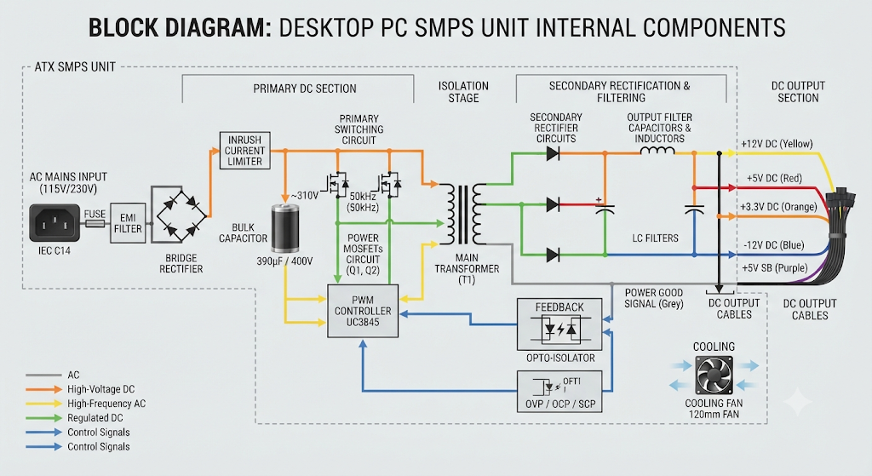

Task-3 Take photos or find clear images online of the following power connectors: ATX 24-pin motherboard connector, SATA power connector, Molex connector, and PCIe 6/8-pin connector. For each, write its name, the devices it powers, and one safety tip for connecting/disconnecting it.

Here are the details, images, and safety tips for the four essential PC power connectors:

1. ATX 24-Pin Motherboard Power Connector

- Name: ATX 24-Pin Motherboard Power Connector

- Devices it powers: The main motherboard, supplying primary electrical rails (+3.3V, +5V, +12V) to the chipset, onboard controllers, RAM slots, and PCIe expansion slots.

- Safety Tip: Always press down firmly on the integrated plastic locking latch before pulling the connector straight up to avoid cracking the motherboard's soldered socket or bending its pins.

2. SATA Power Connector
- Name: SATA Power Connector

- Devices it powers: Internal 3.5-inch hard disk drives (HDDs), 2.5-inch solid-state drives (SSDs), and optical disc drives.

- Safety Tip: Grip the wide plastic connector housing firmly and pull straight back when disconnecting; never yank on the thin wires, as this can easily strip or snap the internal crimp connections.

3. Molex Power Connector
- Name: 4-Pin Molex Power Connector

- Devices it powers: Legacy IDE hard drives, older optical drives, case cooling fans, and fan hubs or LED lighting controllers.

- Safety Tip: Molex connectors are notoriously tight and prone to sticking—wiggle the connector gently side-to-side while pulling rather than applying brute force to prevent pulling out the wires.

4. PCIe 6/8-Pin Power Connector
- Name: PCIe 6/8-Pin Power Connector

- Devices it powers: Dedicated graphics cards (GPUs) that require auxiliary power beyond the 75W provided directly by the motherboard slot.

- Safety Tip: Ensure the spring-loaded plastic latch on top of the connector is fully depressed and disengaged before attempting to unplug it from the graphics card.

Task-4 Imagine you are setting up a new gaming PC. List the steps you would follow to connect the SMPS to the motherboard, graphics card, and storage devices, mentioning which specific cables and connectors are used for each.

Step 1: Connecting to the Motherboard
The motherboard requires two primary power connections to run the chipset, memory, PCIe slots, and the processor.

- Main 24-Pin ATX Power Cable:

  - Connector: A large, thick 24-pin block (often split into a 20+4 pin configuration).

  - Action: Locate the 24-pin power slot on the right-hand side of the motherboard. Align the plastic retention clip on the cable with the latch on the slot and push down firmly until you hear or feel a secure click.

- 8-Pin (4+4) EPS CPU Power Cable:

  - Connector: An 8-pin connector that can usually split into two 4-pin pieces.

  - Action: Locate the 8-pin (or dual 8-pin) CPU power header situated near the top-left corner of the motherboard, close to the processor socket. Plug the connector in, ensuring the shape of the pins matches the socket layout. This supplies dedicated power to the CPU.

Step 2: Connecting to the Graphics Card (GPU)
High-performance gaming GPUs draw significant power and require direct lines from the SMPS.

- 6+2 Pin PCIe Power Cables or 12VHPWR Cable:

  - Standard GPUs: Use 6+2 pin PCIe power cables (frequently labeled "PCIe" on modular power supplies). Clip the "+2" section to the 6-pin portion if your GPU requires an 8-pin connection, or leave the "+2" hanging if it only needs a 6-pin connection. Plug them securely into the power receptacles on the graphics card until the retention clip clicks.

  - Modern High-End GPUs (e.g., RTX 40-series/50-series): Use a native 12VHPWR or 12V-2x6 cable if your SMPS supports ATX 3.0/3.1 standards. Ensure the connector is pushed in completely and straight—there should be zero gap between the plug and the socket to prevent overheating.

Step 3: Connecting to Storage Devices
Powering your storage drives depends on whether you are using traditional drives or modern solid-state form factors.

- SATA Power Cable:

  - Connector: A flat, wide, multi-pin black connector designed specifically for data drives.

  - Action: For 2.5-inch SATA SSDs or 3.5-inch mechanical hard drives, plug the L-shaped SATA power connector from the SMPS cable into the matching wide power port on the back of the drive.

- Note on M.2 NVMe SSDs: If your system uses M.2 NVMe SSDs installed directly into the motherboard slots, no SMPS cable is required. These drives draw power directly from the motherboard's M.2 slot.

Pro-Tips for Cable Management
- Route Behind the Tray: Route all cables through the rubber grommets to the back of the motherboard tray before plugging them in to maintain optimal airflow and clean aesthetics inside the case.

- Double-Check Modular Connections: If using a fully modular SMPS, ensure the component-end cables are firmly plugged into the correct labeled ports on the power supply unit itself (e.g., CPU, PCIe, SATA) before mounting the case panels.

